**Four patterns regression model**







**1 V1 v4 hypertension status transition**

Hang in there

I’m elevated!



Well, Is this real?

**Nine patterns, sorted**



**Bpta for each group**





**Regression model**





**2. Mixed effect model _ Annual bp change by bpta groups**

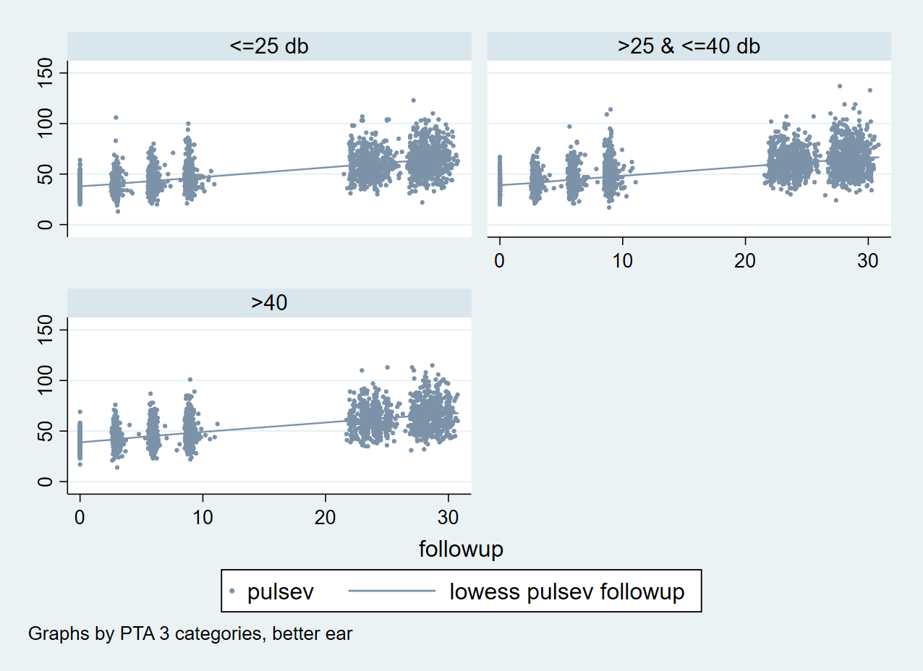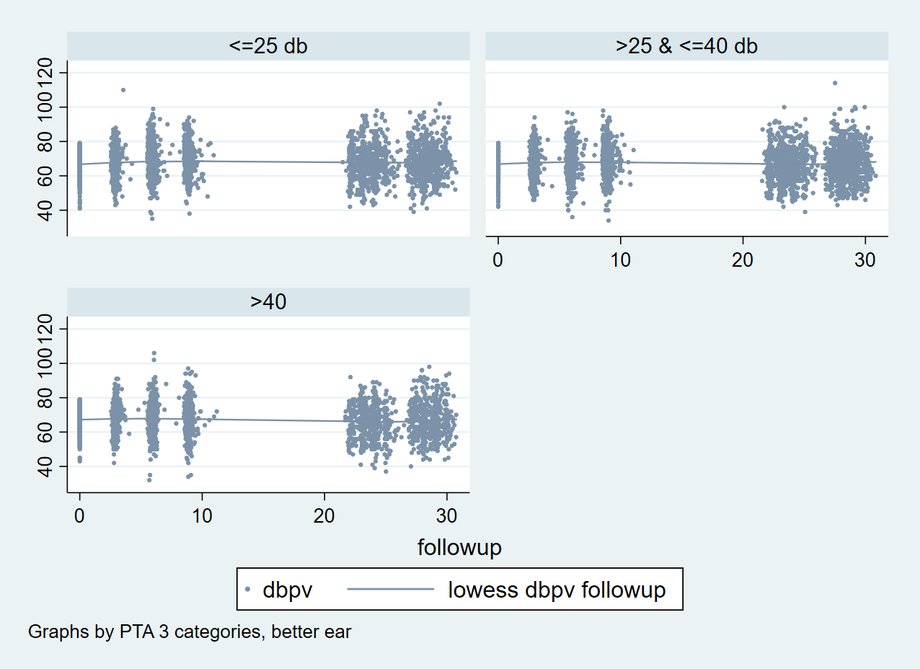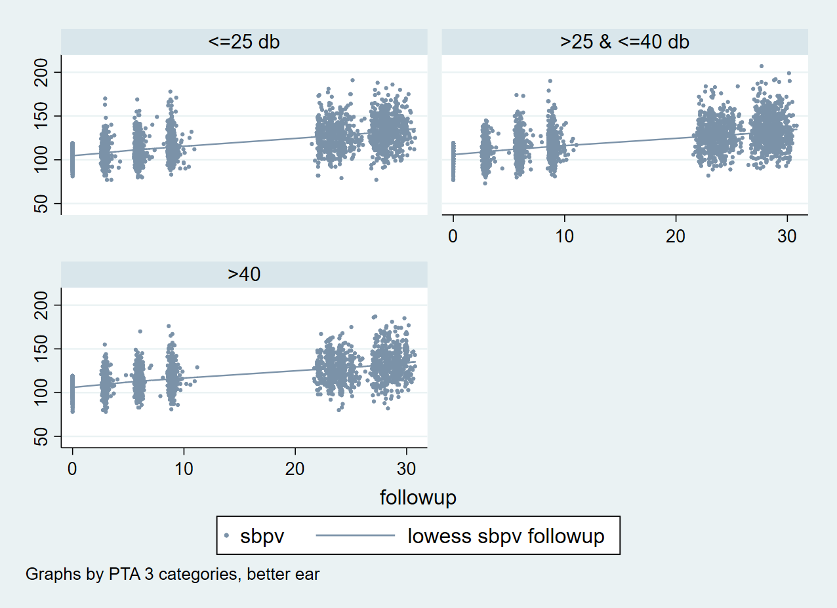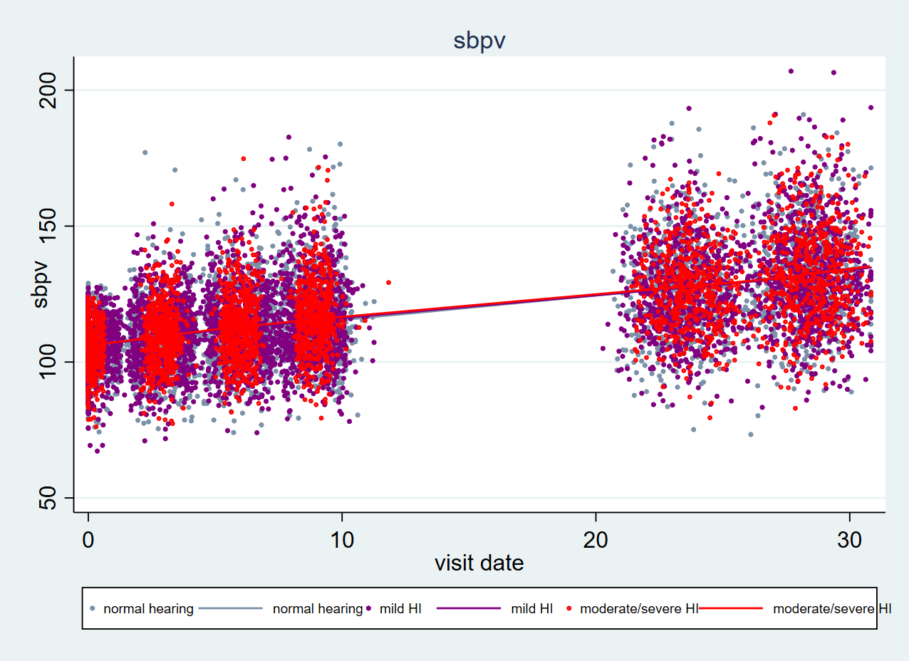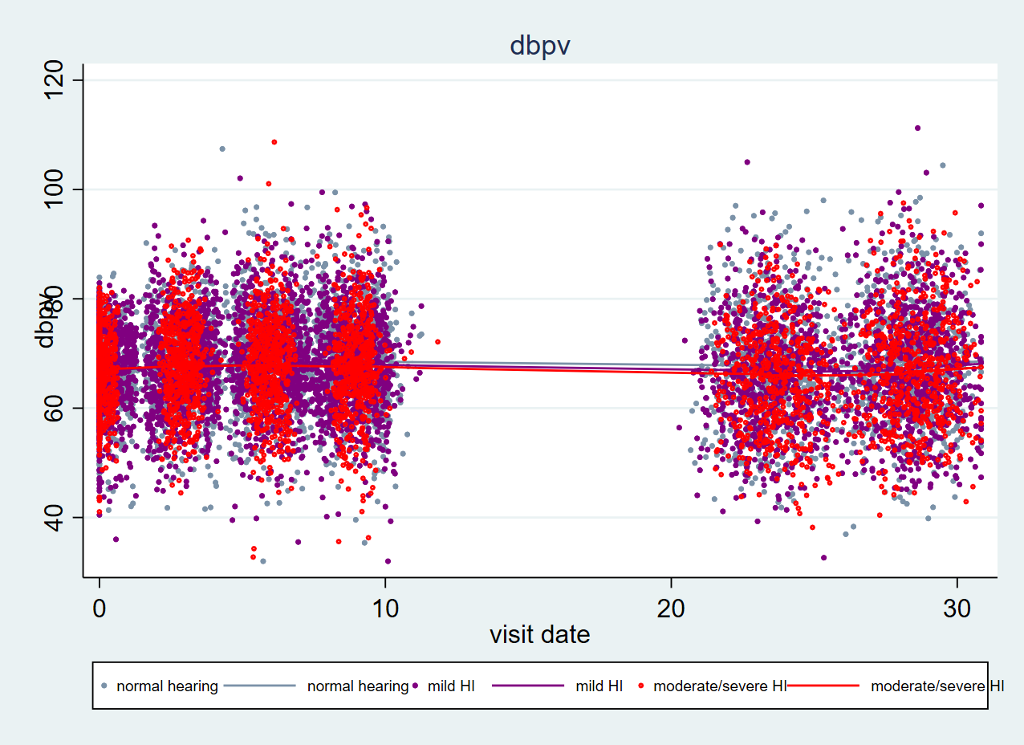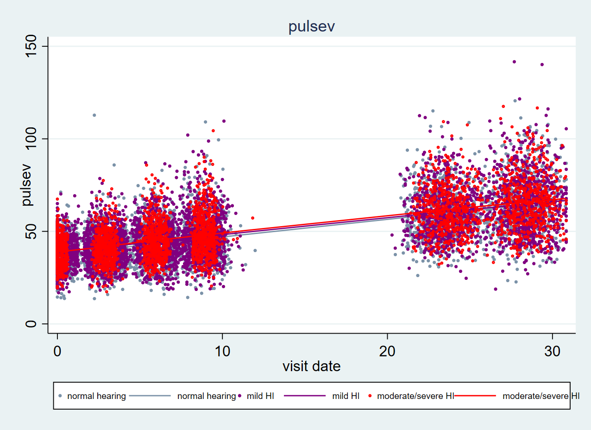

Mixed-effects ML regression Number of obs = 11,370

Group variable: id Number of groups = 1,914







**Detailed model building:**

[**https://drive.google.com/file/d/1IwfSE2pckgdMZk2-LMyvc5j_wdPWctdG/view?usp=sharing**](https://drive.google.com/file/d/1IwfSE2pckgdMZk2-LMyvc5j_wdPWctdG/view?usp=sharing)

**3.Data driven approach for BP percent change classification**

**Summary data**

[**https://drive.google.com/file/d/1GGXe-zEUJv8PNwps46J3IfXqoIO-b58a/view?usp=sharing**](https://drive.google.com/file/d/1GGXe-zEUJv8PNwps46J3IfXqoIO-b58a/view?usp=sharing)

**Comments & Recommendation**

* + - * There is a great heterogeneity. Some participants’ BP are increasing while some are decreasing, especially for DBP.

Based on the ranges and percentiles of BP percent change, the following threshold is recommended

* + - * Potential cut off for SBP : **10%** increase for v1- v4 ( 5% - 10% participants ) , **20%** increase for v4 – v6 ( 5% - 10% participants )
      * Potential cut off for DBP **: 5%** decrease for v1 – v4 (around 10 % participants) **; 10 %** decrease for v4- v6 (around 10 % participants) **; 5%** increase for v1 – v4 , **15 %** increase for v4 – v6
      * Potential cut off for Pulse Pressure : **20%** increase for v1- v4 ( 5% - 10% participants ) , **40%** increase for v4 – v6 ( 5% - 10% participants )

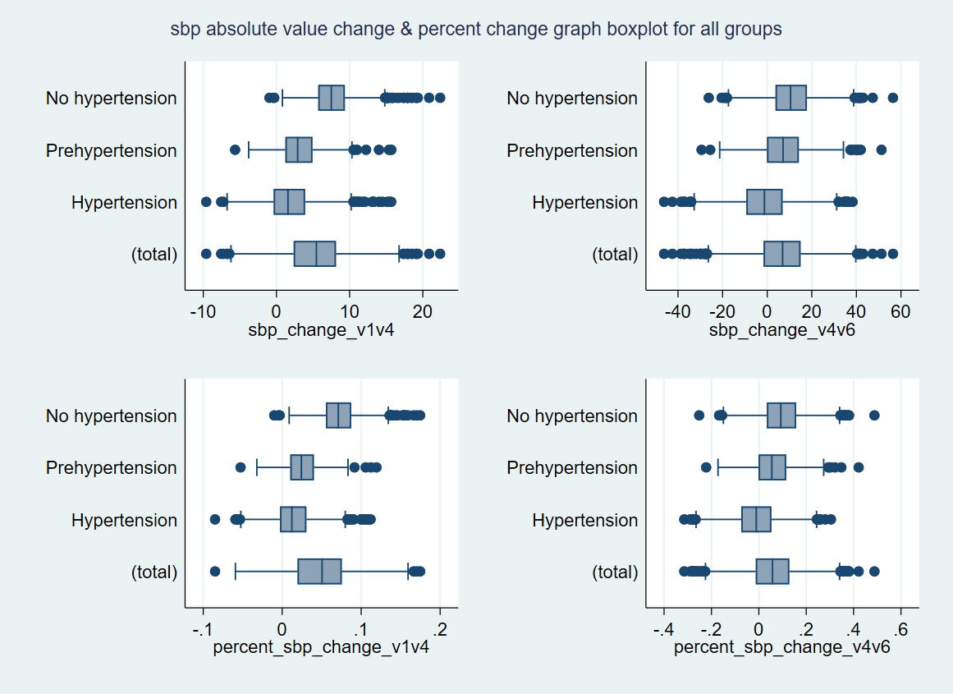

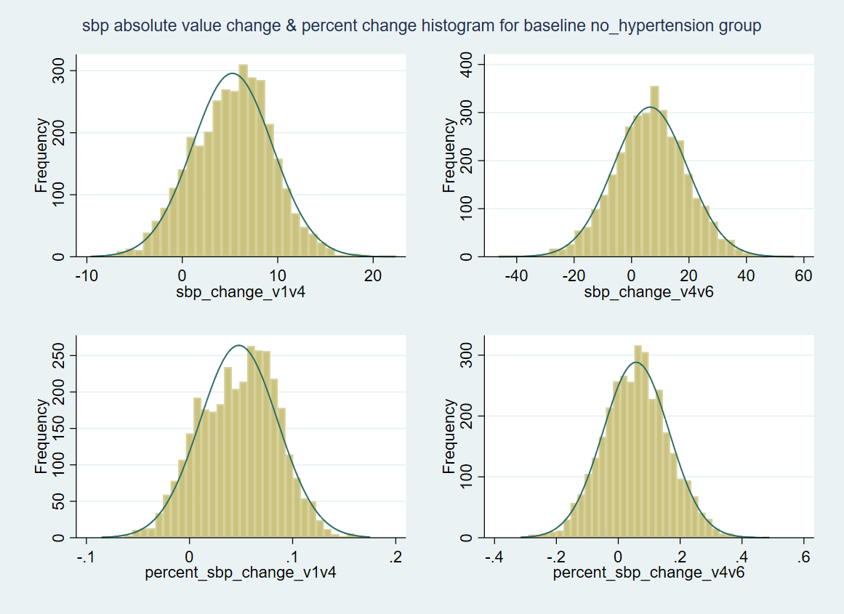

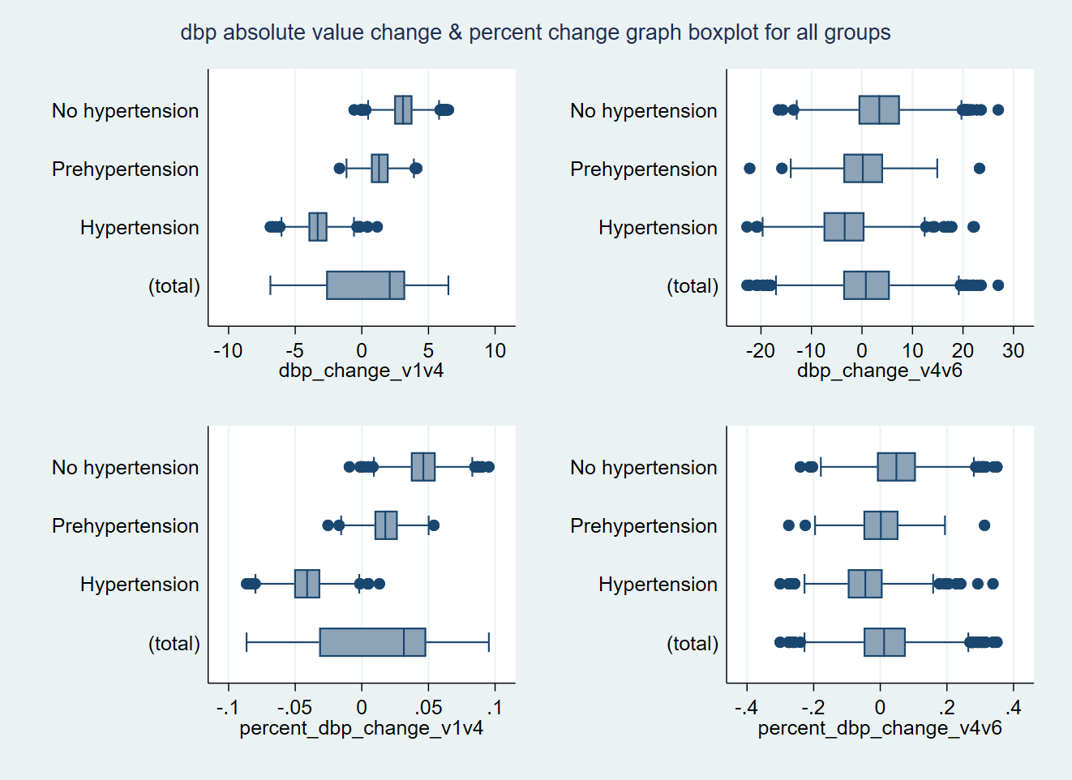

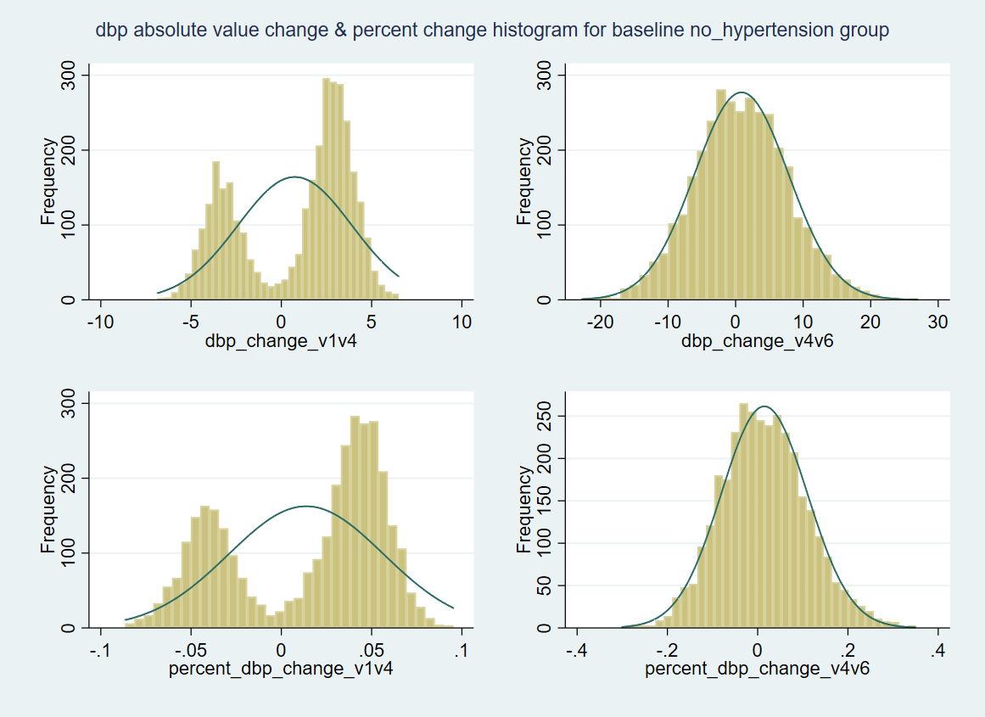

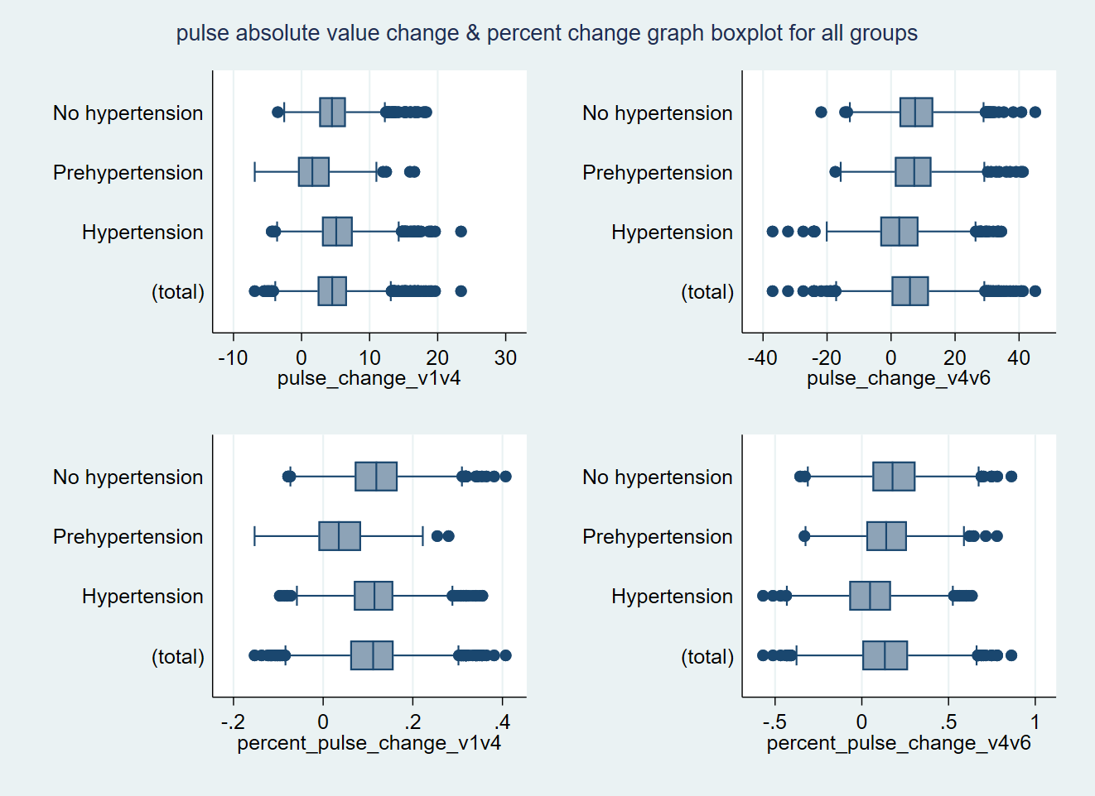

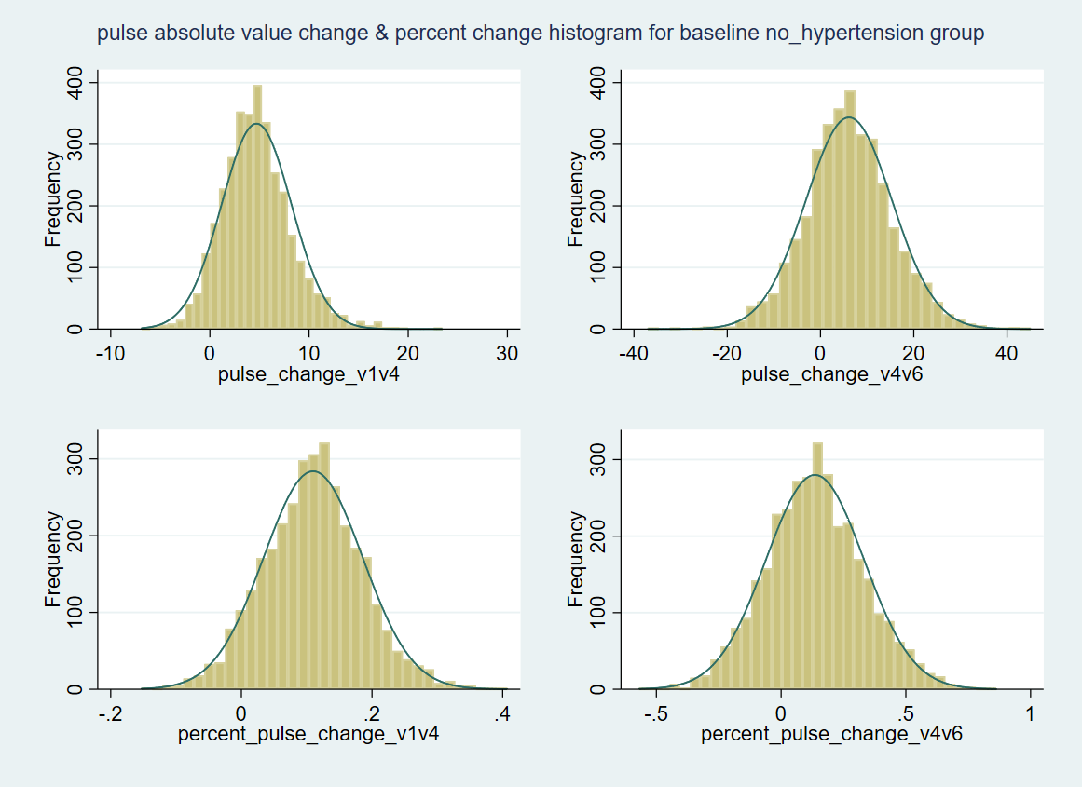

**\*\*\*\*\*\*\*\*\*\*\*\*\*\*\*\*\*\*\*\*\*\*\* data driven approach classification *******************************8**









**MODEL results**



**\*\*\*\*\*\*\*\*\*\*\*\*\*\*\*\*\*\*\*\*\*\*\*\*\*\*\*\*Archived ***************20180102 \*\*\*\*\*\*\*\*\*\*\*\*\*\*\*\*\*\*\*\*\*\*\*\*\*\*\*\*\*\***

**Hypertension classification comparison between AHA guideline pre vs post change**

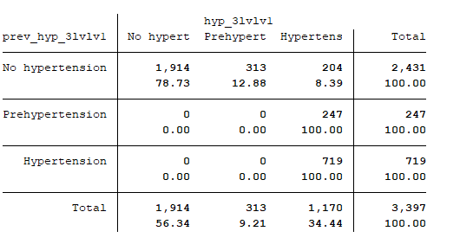

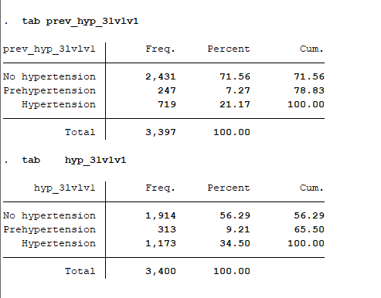

|  |  |  |  |  |  |  |  |  |  |  |
| --- | --- | --- | --- | --- | --- | --- | --- | --- | --- | --- |
| Group | Baseline hypertension status | % ΔSbp i, 10 – 30 | % ΔSbp i, 10 – 30 | Number | Percent |  | Estimated value | Estimated  Difference | 95% CI | P value |
| 1 | No hypertension | stable | stable | 907 | 26.7 |  | 33.43 | Reference | | |
| 2 | No hypertension | stable | increase | 957 | 28.17 |  | 32.82 | -0.33 | -1.45,0.79 | 0.57 |
| 3 | No hypertension | stable | decrease | 116 | 3.41 |  | 33.73 | -0.71 | -3.09,1.67 | 0.56 |
| 4 | No hypertension | increase | stable | 131 | 3.86 |  | 33.29 | 0.20 | -2.06,2.46 | 0.86 |
| 5 | No hypertension | increase | increase | 303 | 8.92 |  | 33.52 | 0.69 | -0.92,2.31 | 0.40 |
| 6 | No hypertension | increase | decrease | 17 | 0.5 |  | 35.44 | 4.13 | -1.78,10.0 | 0.17 |
| 7 | Prehypertension | stable | stable | 144 | 4.24 |  | 34.68 | 1.85 | -0.33,4.03 | 0.096 |
| 8 | Prehypertension | stable | increase | 52 | 1.53 |  | 29.50 | -2.62 | -6.07,0.83 | 0.14 |
| 9 | Prehypertension | stable | decrease | 50 | 1.47 |  | 32.35 | -1.84 | -5.35,1.67 | 0.30 |
| 10 | Prehypertension | increase | stable | 1 | 0.03 |  | 15.00 | -8.87 | -33.0,15.3 | 0.47 |
| 11 | Hypertension | stable | stable | 378 | 11.13 |  | 32.10 | -1.22 | -2.72,0.29 | 0.11 |
| 12 | Hypertension | stable | increase | 97 | 2.86 |  | 34.95 | 2.11 | -0.51,4.72 | 0.11 |
| 13 | Hypertension | stable | decrease | 241 | 7.09 |  | 33.67 | 0.67 | -1.10,2.45 | 0.46 |
| 14 | Hypertension | increase | stable | 1 | 0.03 |  | 25.00 | -8.51 | -32.7,15.6 | 0.49 |
| 15 | Hypertension | increase | increase | 2 | 0.06 |  | 21.88 | -11.9 | -29.0,5.22 | 0.17 |

**Table 3. Better ear PTA value estimates and differences in better ear PTA value by 30 year systolic blood pressure change group**

|  |  |  |  |  |  |  |
| --- | --- | --- | --- | --- | --- | --- |
| Group | Baseline hypertension status | % ΔSbp i, 10 – 30 | % ΔSbp i, 10 – 30 | Number | Percent |  |
| 1 | No hypertension | stable | stable | 500 | 14.71 |  |
| 2 | No hypertension | stable | increase | 541 | 15.91 |  |
| 3 | No hypertension | stable | decrease | 39 | 1.15 |  |
| 4 | No hypertension | increase | stable | 252 | 7.41 |  |
| 5 | No hypertension | increase | increase | 565 | 16.62 |  |
| 6 | No hypertension | increase | decrease | 17 | 0.50 |  |
| 7 | Prehypertension | stable | stable | 161 | 4.74 |  |
| 8 | Prehypertension | stable | increase | 124 | 3.65 |  |
| 9 | Prehypertension | stable | decrease | 23 | 0.68 |  |
| 10 | Prehypertension | increase | stable | 2 | 0.06 |  |
| 11 | Prehypertension | increase | increase | 3 | 0.09 |  |
| 12 | Hypertension | stable | stable | 687 | 20.21 |  |
| 13 | Hypertension | stable | increase | 200 | 5.88 |  |
| 14 | Hypertension | stable | decrease | 271 | 7.97 |  |
| 15 | Hypertension | increase | stable | 8 | 0.24 |  |
| 16 | Hypertension | increase | increase | 4 | 0.12 |  |
| 17 | Hypertension | increase | decrease | 2 | 0.06 |  |
| 18 | Hypertension | decrease | decrease | 1 | 0.03 |  |

Note: Change after AHA guideline is highlighted

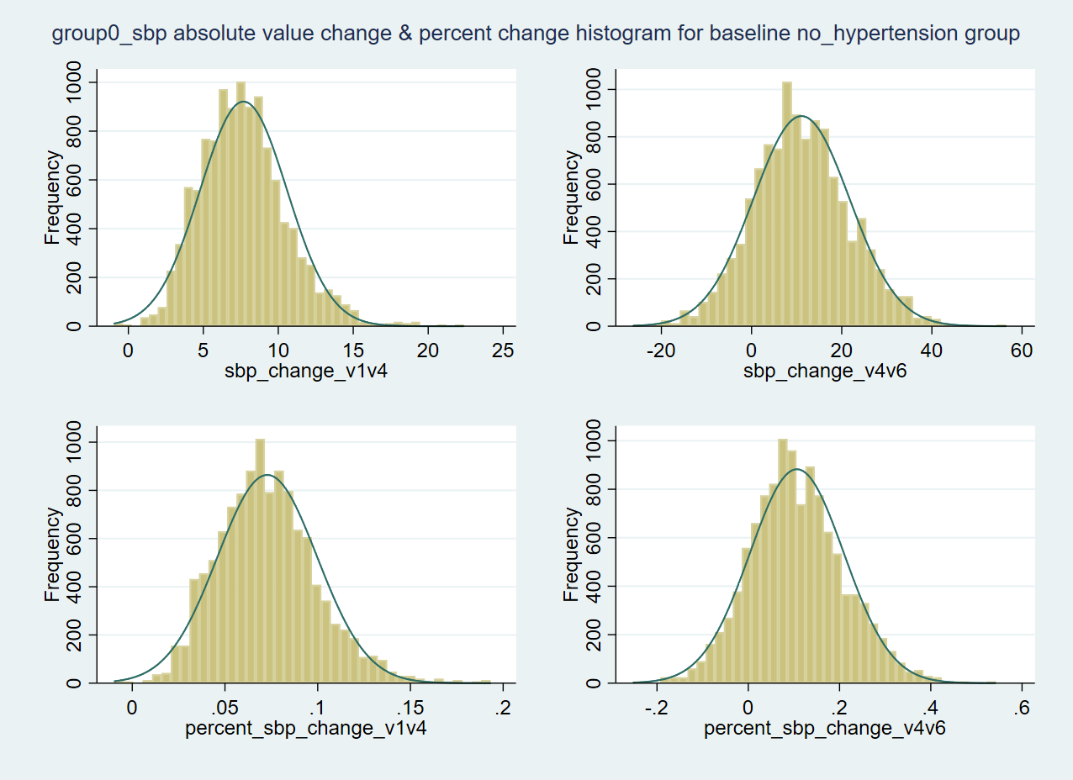

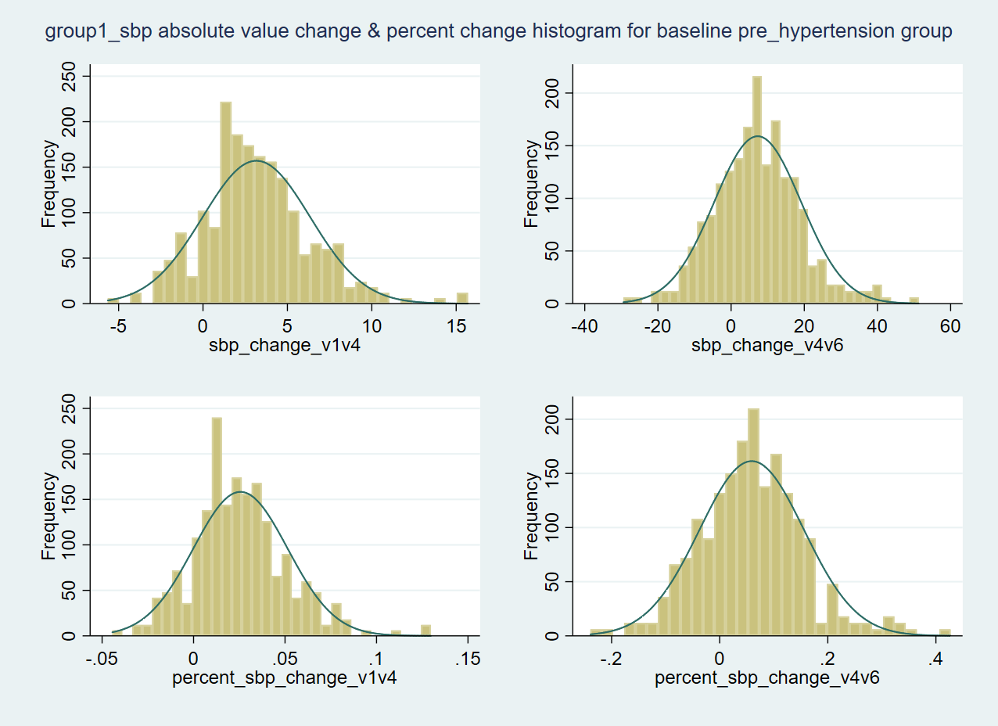

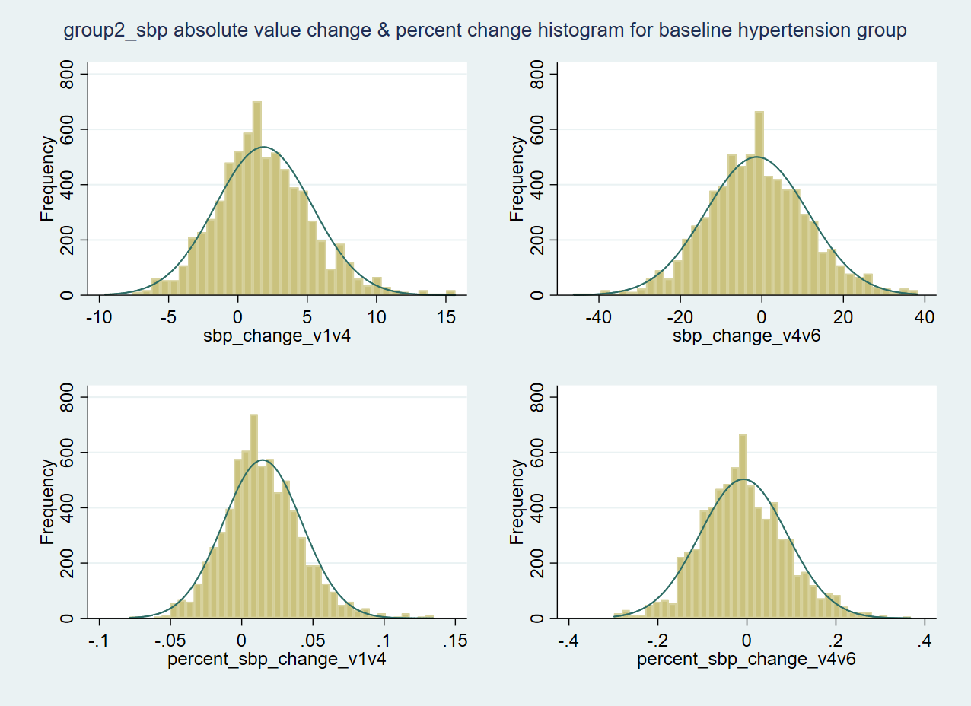

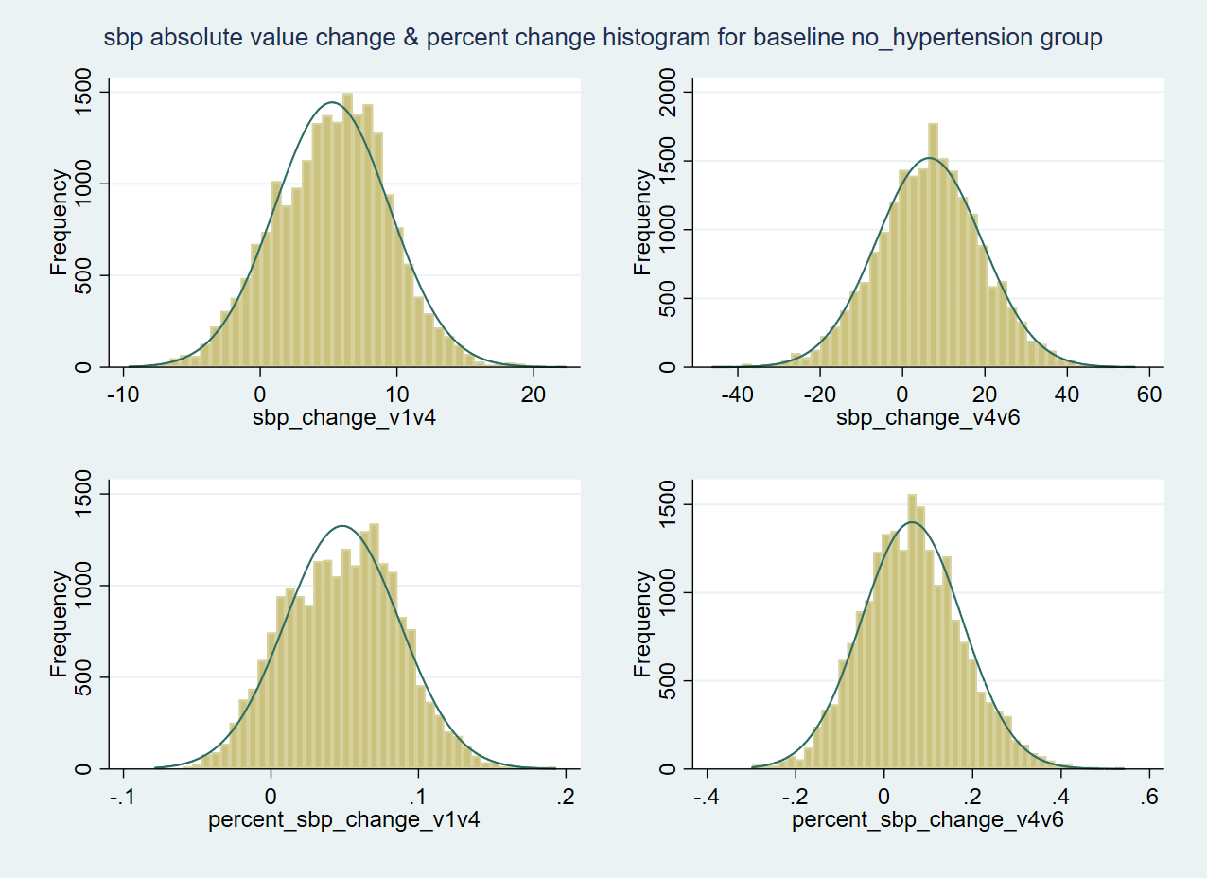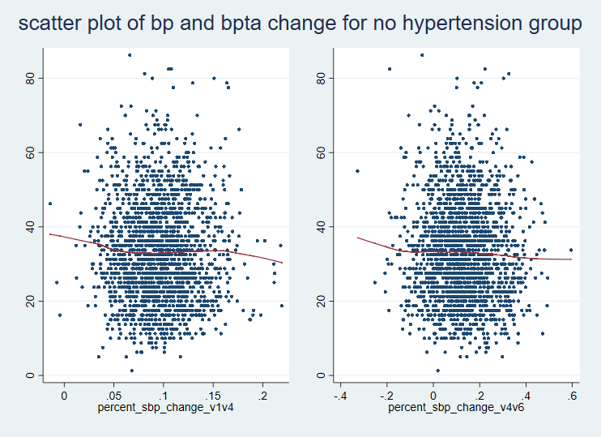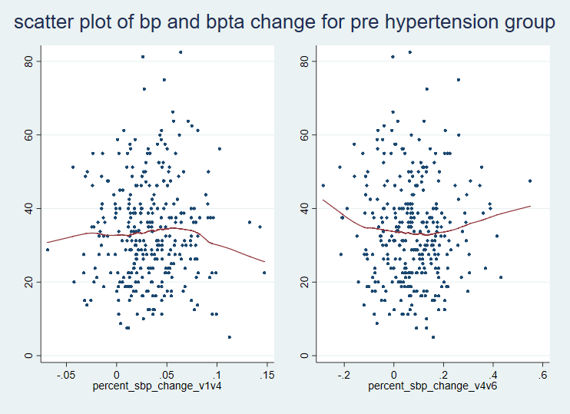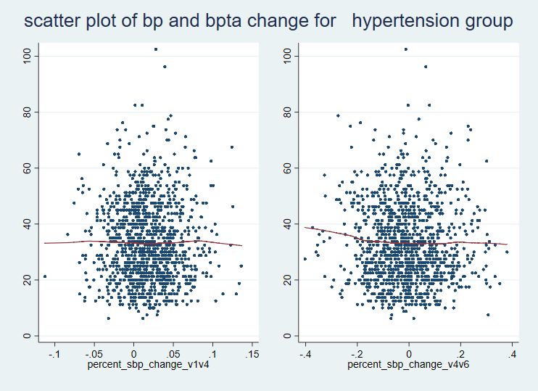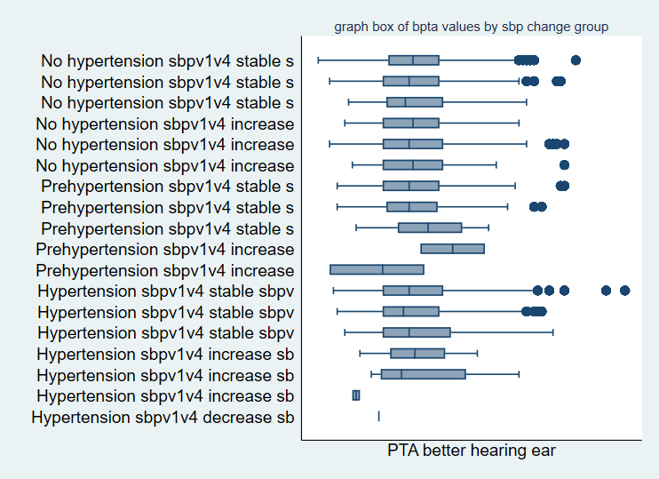

************************************************ Archived *********************************************************

Model Building:

* Add linear Spline at year 10 (visit 4)
* Unstructed model fails to convert, after comparing AIC and BIC with models with different covariance structures, we choose to use independent covariance structures.
* Sbpij = β0 + β1(group)+ β2(t1) + β3(t2) + β3(group*t1) + β4(group*t2) + β5(medusa)+ β6(age) + β7(sex) + β8(racecenter) + β9(education) + β10(diabetes) + β11(bmi) + β12(smoking) + β13(drinking) + $u_{0i}$ + $u_{1i}$ (t1) + $u_{2i}$ (t2) + ε*ij*

No hypertension group

* ΔSbp i, 0 - 10 = 10 * (estimated annual change from 0 -10 years + random slope ) = 10* (β2 + )
* ΔSbp i, 10 – 30 = 20 * (estimated annual change from 10 – 30 years + random slope ) = 20* (β2 + )
* % ΔSbp i, 0 - 10 = ( ΔSbp i, 0 - 10  / Sbpi,0) * 100%
* % ΔSbp i, 10 – 30 = ( ΔSbp i, 10 - 30  / Sbpi,10) * 100%

**Table 3. Better ear PTA value estimates and differences in better ear PTA value by 30 year systolic blood pressure change group**

|  |  |  |  |  |  |  |  |  |  |  |
| --- | --- | --- | --- | --- | --- | --- | --- | --- | --- | --- |
| Group | Baseline hypertension status | % ΔSbp i, 10 – 30 | % ΔSbp i, 10 – 30 | Number | Percent |  | Estimated value | Estimated  Difference | 95% CI | P value |
| 1 | No hypertension | stable | stable | 907 | 26.7 |  | 33.43 | Reference | | |
| 2 | No hypertension | stable | increase | 957 | 28.17 |  | 32.82 | -0.33 | -1.45,0.79 | 0.57 |
| 3 | No hypertension | stable | decrease | 116 | 3.41 |  | 33.73 | -0.71 | -3.09,1.67 | 0.56 |
| 4 | No hypertension | increase | stable | 131 | 3.86 |  | 33.29 | 0.20 | -2.06,2.46 | 0.86 |
| 5 | No hypertension | increase | increase | 303 | 8.92 |  | 33.52 | 0.69 | -0.92,2.31 | 0.40 |
| 6 | No hypertension | increase | decrease | 17 | 0.5 |  | 35.44 | 4.13 | -1.78,10.0 | 0.17 |
| 7 | Prehypertension | stable | stable | 144 | 4.24 |  | 34.68 | 1.85 | -0.33,4.03 | 0.096 |
| 8 | Prehypertension | stable | increase | 52 | 1.53 |  | 29.50 | -2.62 | -6.07,0.83 | 0.14 |
| 9 | Prehypertension | stable | decrease | 50 | 1.47 |  | 32.35 | -1.84 | -5.35,1.67 | 0.30 |
| 10 | Prehypertension | increase | stable | 1 | 0.03 |  | 15.00 | -8.87 | -33.0,15.3 | 0.47 |
| 11 | Hypertension | stable | stable | 378 | 11.13 |  | 32.10 | -1.22 | -2.72,0.29 | 0.11 |
| 12 | Hypertension | stable | increase | 97 | 2.86 |  | 34.95 | 2.11 | -0.51,4.72 | 0.11 |
| 13 | Hypertension | stable | decrease | 241 | 7.09 |  | 33.67 | 0.67 | -1.10,2.45 | 0.46 |
| 14 | Hypertension | increase | stable | 1 | 0.03 |  | 25.00 | -8.51 | -32.7,15.6 | 0.49 |
| 15 | Hypertension | increase | increase | 2 | 0.06 |  | 21.88 | -11.9 | -29.0,5.22 | 0.17 |

Note:

1. Stable group was defined as blood pressure change between -10% - 10% ; increase group was defined as blood pressure increase more than 10%; Decrease group was defined as blood pressure decrease more than 10%

2. Model was adjusted for age, sex, race center, education.

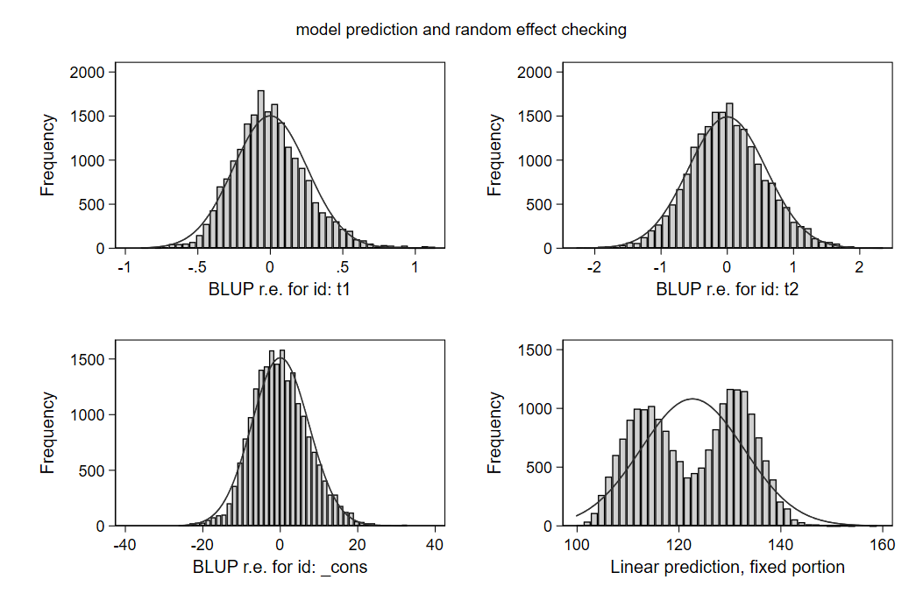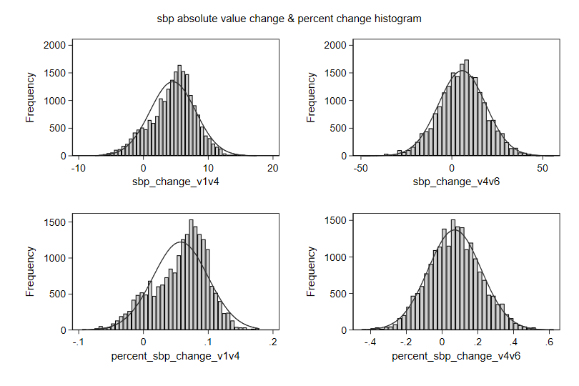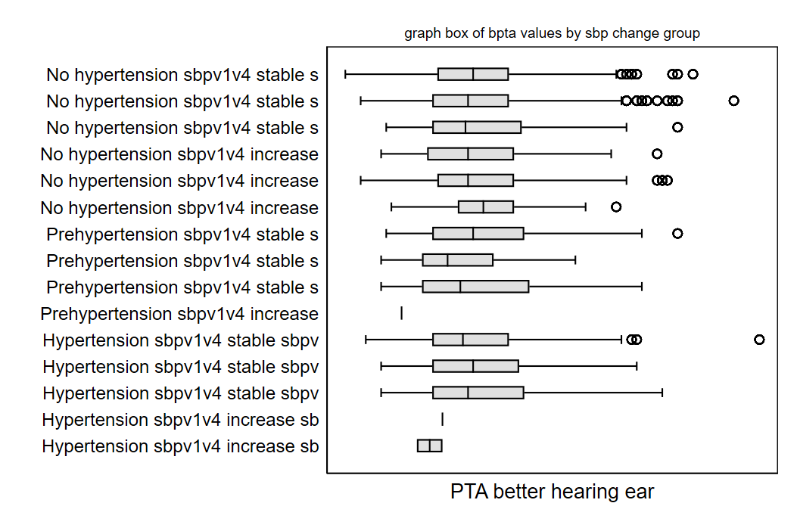

**Supplementary**



